COMPANY
Legacy Hospitality and Entertainment Group, LLC

LOCATIONS
WENATCHEE VALLEY COLLEGE CAFETERIA

Location Address:
1300 Fifth Street,
Wenatchee, WA 98801

POSITIONS AVAILABLE
- Team Lead

PAY
Up to $20 an hour

EMPLOYMENT TYPE
Seasonal with possibility of permanent

Join a fast-paced, friendly team serving up great food and great vibes! We're looking for energetic, dependable team members to keep things running smoothly.



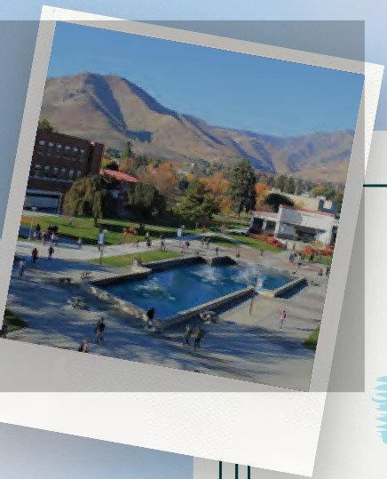



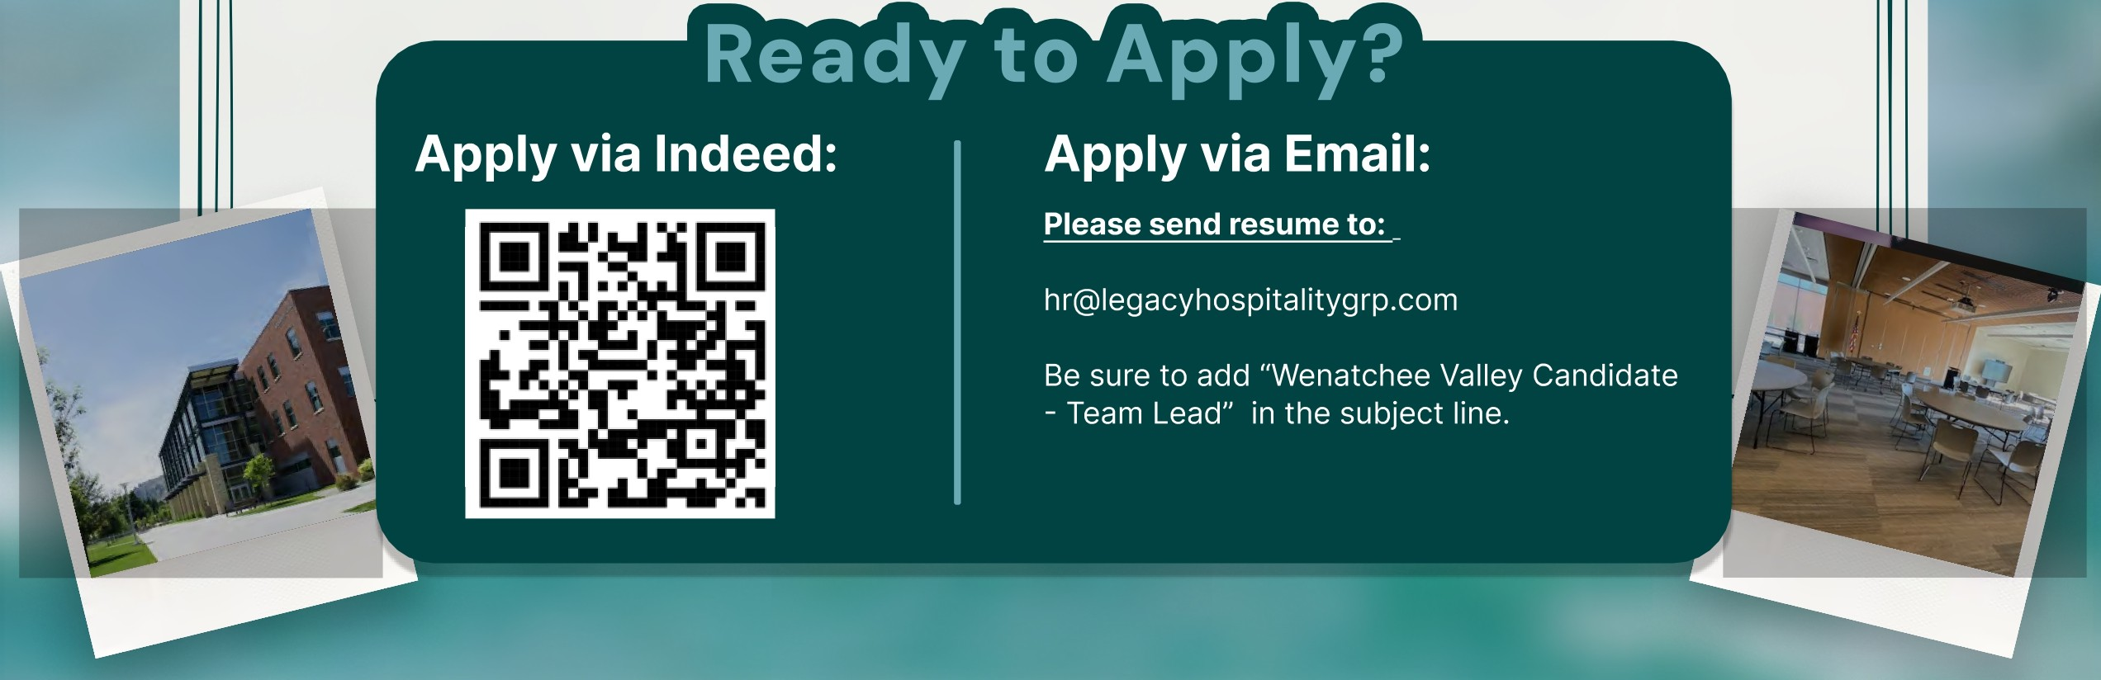
- Take customer orders with a smile
- Prepare and serve food items
- Keep work areas clean and organized
- Help create a friendly and efficient work environment
- Reliable and punctual
- Great customer service skills
- Able to work on your feet in a busy setting
- Team player with a positive attitude

