How to Find Your Advisor’s Information on ctcLink

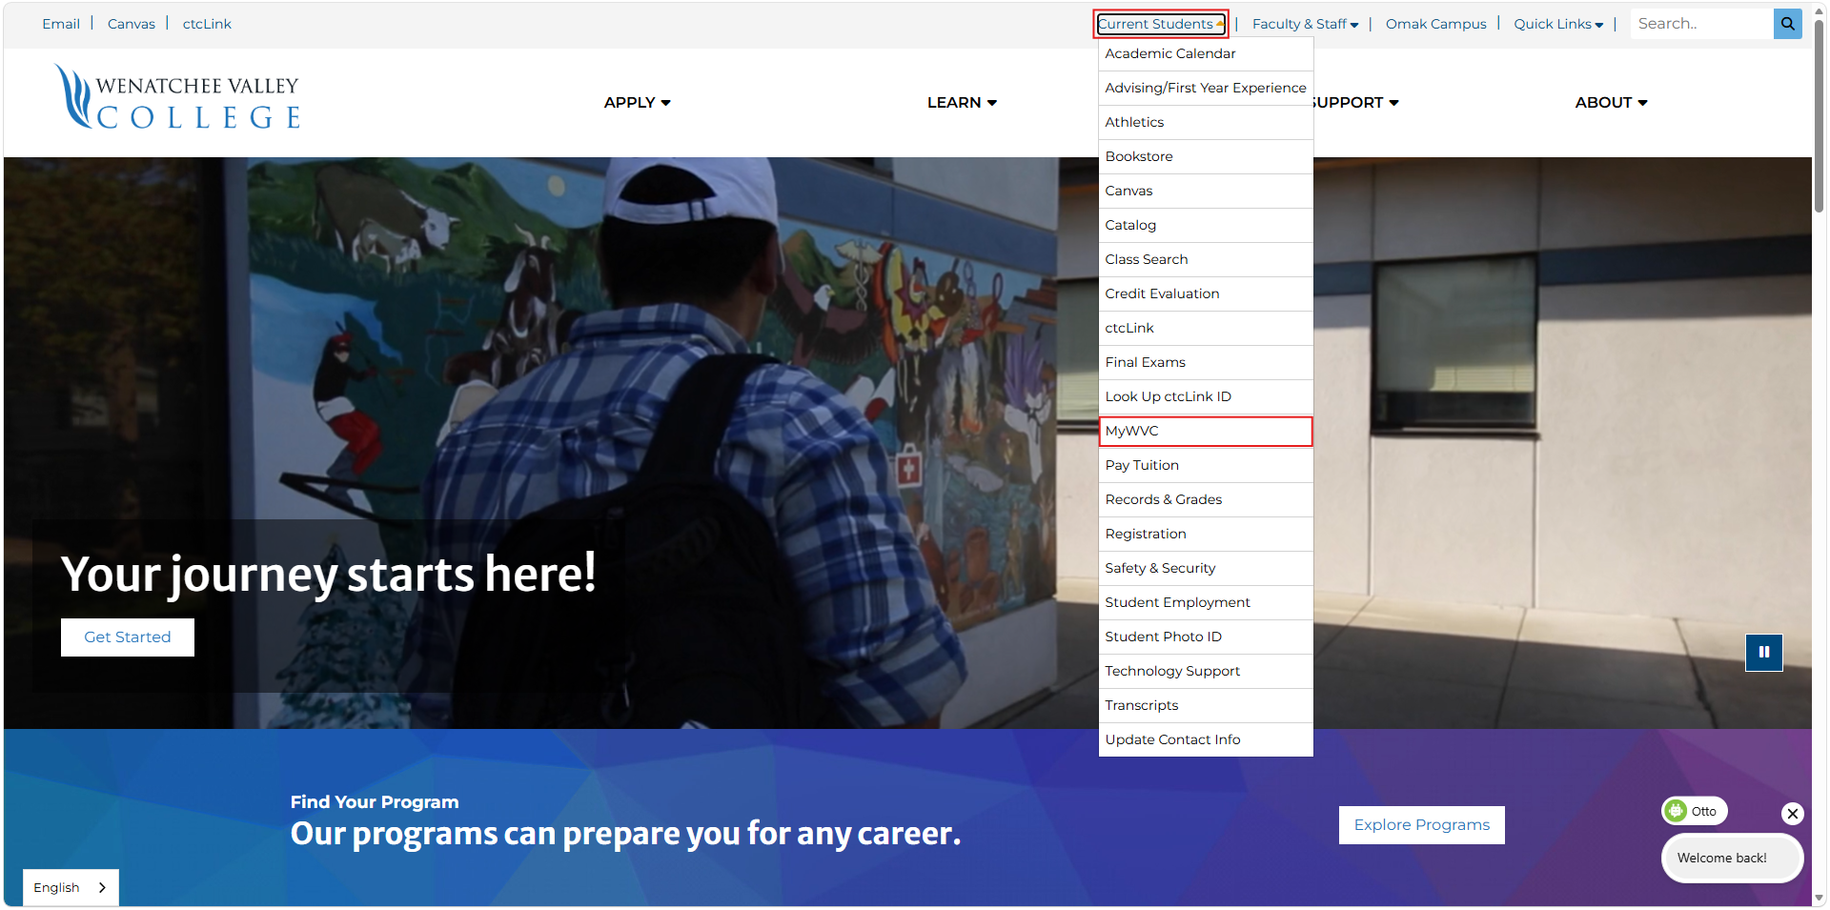
1. From www.wvc.edu, select Current Students and then MyWVC from the dropdown menu

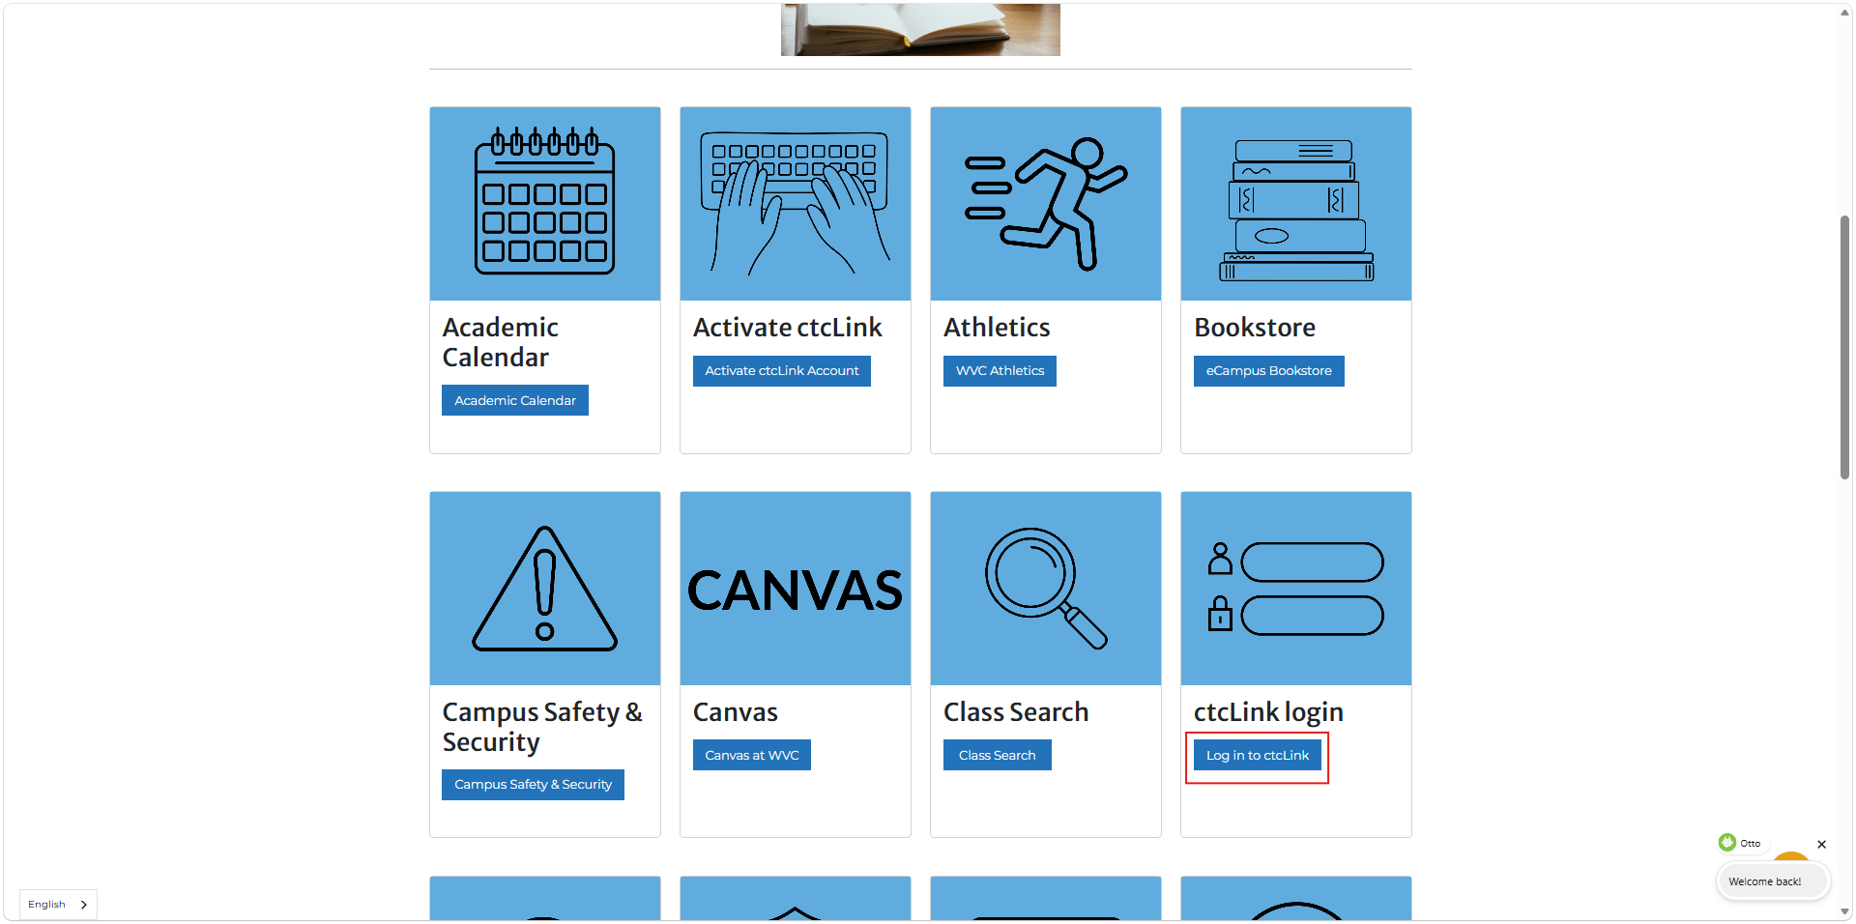
2. Select ctcLink login

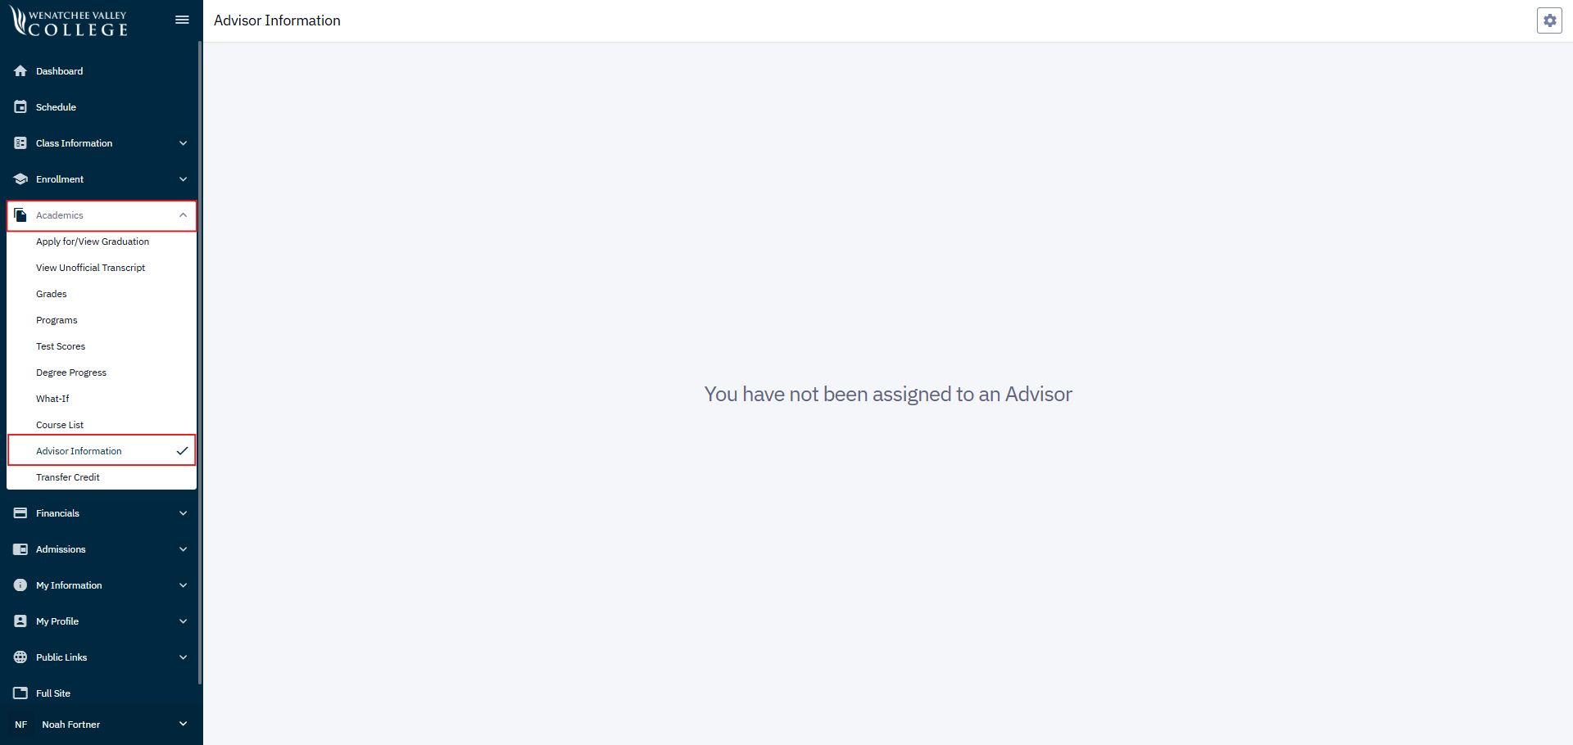
3. Once you have logged in, select Academics from the menu on the left and then Advisor Information. If you have been assigned an advisor, their information will display on the right.

